8th U. S. National Combustion Meeting

Organized by the Western States Section of the Combustion Institute

and Hosted by the University of Utah

May19-22, 2013

NTC-Affected Ignition of DME by Heated Counterflowing Air

*Sili Deng, Peng Zhao, Delin Zhu and Chung K. Law*

*1Department of Mechanical and Aerospace Engineering, Princeton University*

*Princeton, NJ 08544, USA*

**Abstract**

An experimental study, supported by computation, was conducted on the coupling of NTC-chemistry and transport in low-temperature ignition, using the nonpremixed counterflow which provided a well-characterized flow time for comparison with the chemical ignition delay time. In particular we were interested to explore if ignition in a strained flow field with a finite residence time could still be fundamentally affected by the low-temperature NTC chemistry, as recently computationally demonstrated for the nonpremixed counterflow of heptane versus heated air. The fuel chosen in this study is dimethyl ether (DME). The presence of low-temperature reactivity was detected by using a photomultiplier tube (PMT) which measured the chemiluminescense from the radicals generated by the low-temperature chemistry. A filter combined with the PMT captured the spectrum around 400 nm, corresponding to the radiation emission of the HCHO molecules. The signal is further processed by a lock-in amplifier to diminish the noise. A highly sensitive infrared camera was also used to visualize the mixing reaction layer, with images clearly showing the diffusion cool flame. Experiments conducted under various fuel boundary concentrations and strain rates showed that ignition affected by the NTC chemistry, relevant at lower air boundary temperatures, was achieved at lower strain rates, and was found to be insensitive to a wide range of fuel concentrations. Both experimental findings agreed well with the computation using detailed chemistry, with the controlling mechanisms identified.

# Introduction

Negative temperature coefficient (NTC) refers to the phenomenon that the ignition delay time of a fuel/air mixture increases with increasing initial temperature within a certain low-temperature range. For example, at 1 atm this range is between 600 and 800K. It indicates that the reactivity of the mixture is non-monotonic to temperature variation, being stronger at lower temperatures. Since it is so essential to the combustion of most hydrocarbon fuels, especially for processes associated with engine knock, the NTC phenomenon has been extensively studied. Most of these studies, however, employed homogenous systems, such as shock tube (Ciezki *et al.* 1993), flow reactor (Wada, 2011), jet stirred reactor (Veloo *et al.* 2013) and rapid compression machines (Mittal *et al.* 2008).

Since non-uniformities invariantly exist in realistic combustion systems, the coupling between the NTC chemistry and convective-diffusive transport processes should be considered. It is reasonable to expect that when the transport time scale becomes comparable to that of the NTC chemical time scale, the two processes will be strongly coupled. By the same reasoning, when the residence time becomes long enough, the NTC chemistry will be decoupled from transport processes and the system response will recover that of the homogenous system. Indeed, Law and Zhao (2012) have recently identified the NTC-affected ignition phenomenon in the counterflow system based on simulation and computational diagnostics, showing the existence of a secondary S-curve, with distinctive ignition and extinction turning points controlled by NTC-chemistry, grafted onto the lower branch of the primary S-curve. Furthermore this secondary S-curve becomes more pronounced at lower strain rates and higher pressures.

The primary objective of the present investigation is to experimentally explore if the subject phenomenon, computationally predicted, indeed exists, and to characterize its response if the exploration is affirmative. The investigation is a challenging one because of the weak reactivity and exothermicity involved, rendering unambiguous detection difficult.

Dimethyl ether (DME) was selected as the fuel for the present study because it is gaseous and is one of the simplest hydrocarbons exhibiting the NTC behavior. Furthermore, detailed reaction mechanisms for low and high temperature DME oxidation (Curran *et al*. 1998, Fischer *et al.* 2000, Curran *et al.* 2000, Zhao *et al.* 2008) have been developed and validated against burner stabilized flames (Kaiser *et al.* 2000), nonpremixed counterflow flame ignition (Zheng *et al.* 2005), laminar flame speeds (Qin *et al*. 2005), and rapid compression machines (Mittal *et al.* 2008), allowing computational simulation and thereby guidance and verification of the experimentation. In particular, the present computation was conducted using a skeletal mechanism of 39 species reduced from the well-validated detailed mechanism of Zhao *et al.* (2008). On the practical side, it is noted that due to its low-sooting characteristics and the capacity to be mass produced from natural gas and biomass, DME has been proposed as a promising alternative diesel fuel and fuel additive for reducing particulate emissions.

# Experimental Investigation

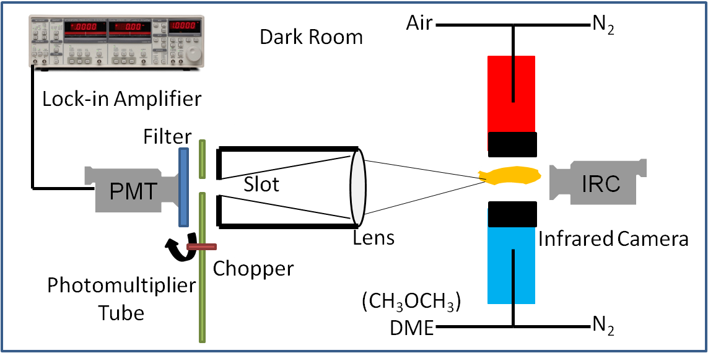

Fig. 1. Schematic of the experimental system

A schematic of the experimental system is shown in Fig. 1. Detailed descriptions of the counterflow experimental apparatus are given in (Fotache *et al.* 1995, Liu *et al.* 2010). Briefly, the counterflow apparatus consists of two vertically oriented opposing quartz nozzles with diameters of 20 mm and separated by 20 mm. A heated air or N2 stream is issued from the upper nozzle and impinges against a room-temperature N2-diluted DME steam issued from the lower nozzle. Both upper and lower streams are shielded by coflowing N2 to diminish disturbance from the environment. An uncoated K-type (Chromel-Alumel) thermocouple is used to measure the maximum temperature at the upper nozzle exit. In a typical counterflow ignition experiment, ignition is achieved by gradually increasing the air boundary temperature until a flame appears. The exit temperature, measured by a thermocouple with radiation correction (Fotache *et al*. 1995), is then defined as the ignition temperature. Single-point laser Doppler velocimetry (LDV) is used to measure the axial flow velocity along the centerline to determine the local strain rate of the flow.

While the above procedure has been successfully usedin previous studies ofignition in the counterflow and stagnation flow, for which the instant of ignition can be observed visually, no bright flame or visually-detectable reaction front could be observed for the present NTC-affected ignition of DME within the temperature range of interests (600-800 K). To facilitate detection of chemical reactivity to the state of ignition, it is noted that experimental studies in homogeneous systems have shown that the NTC-induced cool flames have characteristic chemiluminescence spectra, as well as relatively small but not negligible amount of heat release compared with hot flames (Sheinson *et al.* 1973, Ohta *et al.* 1991). We have thus designed our experiment based on these ignition characteristics, as shown in Fig. 1. Here a Hamamatsu 931B photomultiplier tube (PMT) combined with focusing lens and a Newport filter (10BPF10-400) was used to detect chemiluminescence and reduce noise light signals from the counterflow chamber. The PMT signal was then processed with a SR510 lock-in amplifier to further diminish the noise. On the right part of Fig. 1, an FLIR SC640 infrared camera was used to capture the temperature profile of the flow field, hence the heat release from NTC chemistry. Unlike thermocouple measurement, this nonintrusive method keeps the flow field undisturbed and shows the temperature distribution directly.

Validation results for the experimental system are shown in Figs. 2 and 3. The “M” shaped signal in Fig. 2 shows that the signal captured by the photomultiplier tube and displayed on an oscilloscope is due to chemistry. The signal intensity drops after the replacement of either N2-diluted DME with pure N2 issued from the lower nozzle (at point a), or of air with N2 issued from the upper nozzle (at point c), hence demonstrating that the signal is due to the presence of both air and DME. Since the replacement of air with the same flow rate of N2 does not change the temperature profile of the flow field, the signal difference between the air/DME and N2/DME cases indicate the existence of NTC chemical activities. Furthermore, heat release from the NTC chemistry is also captured by the infrared (IR) camera. In Fig. 3, the IR images for air/DME and N2/DME cases are denoted by A and B, respectively. The colors of the IR images indicate the IR radiation intensity, thus the temperature, with the red color denoting higher temperatures than the blue color. Comparison shows that the air/DME counterflow generates noticeable amount of heat right above the stagnation plane and at the center section perpendicular to the nozzle axis. A criterion for the onset of NTC-affected ignition can therefore be set based on the IR camera observation. As the air boundary temperature gradually increases, the IR radiation intensity of N2/DME flows is set as the reference state and compared with that of the air/DME signal. The C and D parts of Fig. 3 show the comparison of the air/DME chemically reactive and N2/DME nonreactive cases at ignition. Ignition temperature measurement at the upper nozzle exit and LDV measurement for the local strain rate are then taken as mentioned above.

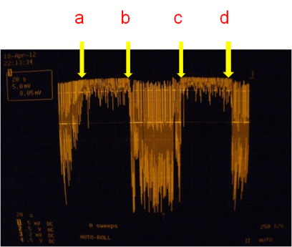

Fig. 2. “M” shaped signal. a. switch Air/DME to Air/N2; b. Switch Air/N2 to Air/DME; c. Switch Air/DME to N2/DME; d. Switch N2/DME to Air/DME

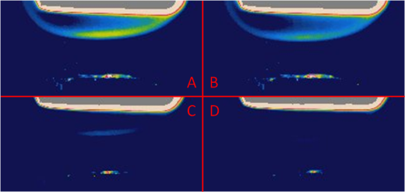

Fig. 3. A/B: heated air or N2 against DME counterflow IR images; C/D: heated air or N2 against DME counterflow IR images at ignition (atmospheric pressure, strain rate 60 /s)

# Computational Investigation

The steady-state response of a one-dimensional reactive system subjected to heat loss can be studied via the S-curve analysis (Law 2006). In such an analysis, a system response such as the maximum temperature or radical concentration is monitored for variations of an imposed parameter such as the air temperature (for a given strain rate of the flow) or the system Damköhler number, which is defined as the characteristic flow time versus the characteristic chemical time. For a global one-step overall reaction with large activation energy, the intrinsically nonlinear Arrhenius kinetics frequently yields multiple solutions characterized by an S-shaped response curve when a system response is plotted against the system Damköhler number, with the lower and upper turning points respectively designate the ignition and extinction states of the system. Such triple-branch S-curves also frequently emerge for simulations using detailed reaction mechanisms, although more complex response curves with multiple ignition-extinction turning points have been obtained, for example for hydrogen oxidation (Kreutz *et al.* 1994, Fotache *et al.* 1998) and methane oxidation (Liu *et al.* 2009).

The governing equations for the counterflow nonpremixed flame are discussed in Giovangigli *et al.* (1987). The numerical code is modified from Smooke *et al.* (1986). It employs the damped Newton’s method and time integration solution scheme to solve the ordinary differential equations with boundary conditions specified on both sides of the potential flow. The S-curve marching is performed using the flame-controlling method of Nishioka *et al*. (1996) with detailed chemistry (Kee *et al.* 1989) and transport database (Kee *et al.* 1983).

The critical states of ignition and extinction can then be assessed through the multiple turning points of the S-curve. The simulation conditions are as follows: the fuel-side mixture consists of DME and nitrogen with a fixed temperature of 300 K, and the oxidizer side is standard air at a high temperature. The separation distance between the two nozzle exits is 20 mm, with the origin being fixed at the fuel exit. To generate an S-curve, marching is performed by either changing the air-side boundary temperature with fixed strain rate or equivalently changing the strain rate with fixed air-side boundary temperature. Following Law and Zhao (2012), the distinct turning points of the NTC S-curve of DME were captured, and the calculated ignition temperature at different strain rates as well as different boundary fuel concentrations are compared with the experimental results.

# Results and Discussion

In Fig. 4, the global response of the system is chosen to be the maximum formaldehyde (HCHO) mole fraction due to its large production rate by the low temperature chemistry, and the NTC S-curve is plotted as a function of air boundary temperature for 30% DME in nitrogen under different strain rates. It is noted that the second ignition state induced by the high temperature chemistry is not shown here. Then, it is seen that the ignition turning point for the NTC S-curve appears at the lower boundary temperature for lower strain rates, although the response is not as sensitive as the extinction turning point. In addition, the low temperature chemistry becomes more pronounced for lower strain rates as seen from the increasing maximum HCHO mole fraction for lower strain rates.

Simulation_K_HCHO_T.tif

Fig. 4. Maximum HCHO mole fraction of 30% DME at different air boundary temperatures under various strain rates.

For the experimental investigation, PMT with special filter for HCHO is used to measure the HCHO chemiluminescence intensity from the mixing layer. In Fig. 5, the chemiluminescence intensity from the HCHO under strain rates 40 /s, 60 /s, 100 /s are measured as a function of the air boundary temperature. Compared with Fig. 4, it again demonstrates that the low temperature chemistry becomes more pronounced under lower strain rates, with more HCHO produced and therefore stronger chemiluminescence from it. Consequently, though limited by system sensitivity, the signal can be detected at lower air boundary temperatures with decreasing strain rates. However, the current PMT system with HCHO filter fails to capture the onset of NTC-affected ignitions; instead, it shows the strength of chemiluminescence after ignition and at higher temperatures. It is also worth noticing that the discrepancy between the signal onset temperatures from experiment and NTC-affected ignition temperature from simulation is primarily due to the low intensity of HCHO chemiluminescence captured by the PMT. On the whole, qualitatively agreement of both stronger HCHO chemiluminescence as well as lower onset temperature detected with the numerical simulation does show the major characteristics of the NTC-transport coupling, which is consistent with previous work by Law and Zhao (2012).

Experiment_K_HCHO_T.tif

Fig. 5. HCHO chemiluminescence intensity at different air boundary temperatures under various strain rates

As discussed in the experimental methodology section, quantitative measurement of the ignition temperature should be made based on the infrared camera observation. For different flow rates, the infrared camera was used to visualize the reaction mixing layer, and LDV was used to measure the velocity profile along the center line to further obtain the local strain rates of each case. In Fig. 6, experimental measurements of the low temperature chemistry induced ignition and the turning points predicted by the NTC S-curve are plotted as function of strain rates. Due to the moderate flow field temperatures and high sensitivity of the thermocouple, ignition temperature error bars are within the size of the symbol. It is seen that very good agreement exists between the experimental observation and the numerical predictions, with the average temperature difference being within 20 K. Sensitivity analysis was carried out to help understand the results and it is shown that the first two most important reactions for promotion of the low temperature chemistry induced ignition are oxygen combination reaction CH2OCH2O2H+O2 ⬄ O2CH2OCH2O2H and isomerization reaction CH3OCH2O2 ⬄ CH2OCH2O2H, and the most important retarding reaction is the β scission reaction CH2OCH2O2H ⬄ OH+2HCHO. Clearly, these two groups of reactions compete for CH2OCH2O2H radicals and function oppositely.

Simulation_Experiment_IgnT_K.tif

Fig. 6. Calculated and observed ignition temperatures of 30% DME under various strain rates

In addition to strain rate effects, the concentration effect is also evaluated, shown and compared with the simulation results in Fig. 7. The simulation result basically demonstrates the insensitive nature of the NTC-affected ignition temperature to the variance of boundary DME concentrations in a large range, under a fixed strain rate of 60 /s. The experimental results again show good agreement with the simulation results. This effect corresponds to the equivalence ratio insensitive nature of the low temperature chemistry, given the fact that first stage delay is insensitive to equivalence ratio in homogeneous autoignition process (Zhao and Law2013).

Simulation_Experiment_IgnT_C.tif

Fig. 7. Ignition temperatures of various DME concentrations under the strain rate of 60 /s

# Conclusions

A photomultiplier tube and infrared camera were employed in the traditional nonpremixed counterflow system to investigate the NTC-chemistry and transport coupling in low temperature chemistry induced ignition, thus to demonstrate the existence of diffusion cool flame. The ignition temperatures, as well as chemiluminescence intensities from formaldehyde of different concentrations of DME in nitrogen under various strain rates were obtained. Both qualitative and quantitative agreements were achieved between the experimental investigation and the numerical simulation.

It was found that with decreasing strain rates, the onset temperature for detectable chemiluminescence decreases, while the intensity for the chemiluminescence from the HCHO generated by the low temperature chemistry also becomes more pronounced. In addition, the ignition temperature of NTC-induced ignition was shown to increase with increasing strain rate and was insensitive to a wide range of boundary fuel concentrations. Such findings demonstrated the important features about low temperature chemistry and provided new tools to study low temperature chemistry and transport coupling process.

**Acknowledgements**

This research was supported by the Combustion Energy Frontier Research Center, an Energy Frontier Research Center funded by the US Department of Energy, Office of Basic Energy Sciences under Award Number DE-SC0001198.

**References**

H.K. Ciezki, G. Adomeit, Comb. Flame 93 (1993) 421–433.

H.J. Curran, W.J. Pitz, C.K. Westbrook, P. Dagaut, J.C. Boettner, M. Cathonnet, Int. J. Chem. Kinet. 30 (1998) 229–241.

H.J. Curran, S.L. Fischer, F.L. Dryer, Int. J. Chem. Kinet. 32 (2000) 741–759.

S.L. Fischer, F.L. Dryer, H.J. Curran, Int. J. Chem. Kinet. 32 (2000) 713–740.

C.G. Fotache, T.G. Kreutz, D.L. Zhu, C.K. Law, Combust. Sci. Technol. 109 (1995) 373-393.

C.G. Fotache, C.J. Sung, C.J. Sun, C.K. Law, Combust. Flame, 112 (1998), 457–471.

V. Giovangigli, M.D. Smooke, Combust. Sci. Technol., 53 (1987), 23–49.

C.K. Law, Combustion Physics, Cambridge University Press, New York (2006).

C.K. Law, P. Zhao, Combust. Flame 159 (3) (2012) 1044-1054.

W. Liu, C.K. Law, T.F. Lu, Int. J. Chem. Kinet. 41 (2009) 764–776.

W. Liu, A.P. Kelley, C.K. Law, Combust. Flame 157 (2010) 1027-1036.

E.W. Kaiser, T.J. Wallington, M.D. Hurley, J. Platz, H.J. Curran, W.J. Pitz, C.K. Westbrook, J. Phys. Chem. A 104 (2000) 8194–8206.

R.J. Kee, F.M. Rupley, J.A. Miller, CHEMKIN-II: A Fortran Chemical Kinetics Package for the Analysis of Gas Phase Chemical Kinetics, Report No. SAND 89-8009B, Sandia National Laboratories, 1989.

R.J. Kee, J. Warnatz, J.A. Miller, Report No. A Fortran Computer Code Package for the Evaluation of Gas-phase Viscosities, Conductivities, and Diffusion Coefficients, SAND 83-8209, Sandia National Laboratories, 1983.

T.G. Kreutz, M. Nishioka, C.K. Law, Combust. Flame, 99 (1994), 758–766.

G. Mittal, M. Chaos, C. J. Sung, and F. L. Dryer, Fuel Processing Technology 89 (12) (2008) 1244-1254.

M. Nishioka, C.K. Law, T. Takeno, Combust. Flame, 104 (1996), 328–342.

Y. Ohta, M. Furutani, Arch. Combust. 11 (1911) 43-52.

X. Qin, Y. Ju, Proc. Combust. Inst., 30 (2005) 233–240.

R.S. Sheinson, F.W. Williams, Combust. Flame 21 (1973) 221-230.

M.D. Smooke, I.K. Puri, K. Seshadri, Combust. Inst., 21 (1986), 1783–1792.

P.S.Veloo, P. Dagaut, C. Togbe, G. Dayma, S.M. Sarathy, C.K. Westbrook, F.N. Egolfopoulos, Proc. Combust. Inst., 34 (2013), 599–606.

T. Wada, Experimental and Theoretical Investigation of Low-Temperature Ignition in a Laminar Flow Reactor, PhD thesis, RWTH Aachen University, Germany, 2011.

Z. Zhao, M. Chaos, A. Kazakov, F.L. Dryer, Int. J. Chem. Kinet. 40 (2008) 1–18.

P. Zhao and C.K. Law, 9th Asia-Pacific Conference on Combustion, Gyeongju, Korea, (2013).

X.L. Zheng, T.F. Lu, C.K. Law, C.K. Westbrook, H.J. Curran, Proc. Combust. Inst., 30 (2005), 1101–1109.